
Premier of Ontario
Legislative Building
Queen's Park
Toronto ON M7A 1A1
Dear Doug Ford,
The Canadian Union of Public Employees is the largest union in Ontario, with over 270,000 dues paying members. We represent workers in practically every town, city, county, district social service board, and unincorporated area in the province. With over 75,000 health care members in Ontario, we are also the largest health care union in the province. The Ontario Council of Hospital Unions/CUPE is the bargaining council for 40,000 CUPE hospital workers in the province. CUPE represents approximately 30,000 Personal Support Workers (PSWs) employed by long-term care homes (LTC), home and community care organizations, and hospitals in Ontario. Personal support work is the largest single category of work carried out by CUPE members in Ontario.
We are writing regarding the Regulations under the Health and Supportive Care Providers Oversight Authority Act, 2021 (“HSCPOA”). OCHU/CUPE previously made submissions regarding the Act in a 2021 Submission to the Standing Committee on Social Policy and in 202x in response to the request for comments on the Proposal to Inform the Regulations of the Act. We rely on these previous submissions but write to highlight some key concerns and issues in the Regulations that, despite our previous submissions, remain unresolved.
Due process
In our previous submissions, we made recommendations to address our concerns about due process. The Regulations do not address these concerns and the following issues remain outstanding and are of serious concern.
- O. Reg. 212/24 Discipline and Appeals specifically excludes registrants and former registrants from being members of the Discipline and Appeals Committees. The exclusion of PSWs from these committees is egregious and is not in line with the standards for other regulated professions. There is also nothing in Regulations regarding an alternative process to identify and address circumstances where a registrant may be incapacitated.
- O. Reg. 212/24 Discipline and Appeals includes some provisions regarding the processes these committees will follow that mirror the Health Professions Procedural Code. However, there are still gaps in terms of due process. Notably, there is no explicit provision providing a right to a written decision with detailed reasons. Further, while there are references to representation and cross-examination, there are no provisions that explicitly provide a right to these crucial elements required for procedural fairness.
- O. Reg. 217/24 Registration sets out the procedure for a Registration Review under s. 28(6) of the Act. However, there is nothing suggesting that the review by the Health Professions Appeal and Review Board (“HPARB”) is more than a written review. The CEO’s unilateral decisions about registration or complaints should be subject to a full right to appeal to the HPARB.
- O. Reg. 219/24 Complaints entrenches the draconian power of the CEO to take “interim urgent action”. These powers should be revoked.
- O. Reg. 212/24 Discipline and Appeals lacks a provision providing for a right to appeal any decision of either Committee to court. There should be a right to a full hearing before the Discipline Committee and the Appeals Committee with a right to appeal any decision of either Committee to the Divisional Court.
Fees
The Regulations do not outline fee amounts for application, registration, or renewal of registration with HSCPOA. We reiterate our concerns about the ability of PSWs to bear the cost of funding the Authority. PSWs cannot be expected to take on extra costs. We strongly recommend that the Ministry reconsider having PSWs bear the cost of funding the Authority, including the funding for Therapy and Counselling (O. Reg. 211/24).
We remain willing and available to meet with the Ministry to discuss these concerns so they can be addressed and HSCPOA can be brought to the same standard as other regulated professions.
Your attention to this request would be greatly appreciated.
Yours sincerely,
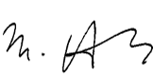
Michael Hurley,
President, Ontario Council of Hospital Unions/CUPE
261 Gerrard Street East, Toronto, ON, M5A 2G1
&
Debra Maxfield
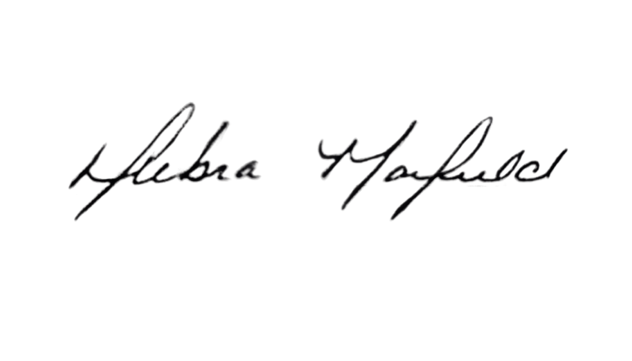
Chair of the Health Care Workers Coordinating Committee

