September 23rd Vote

Melissa Hodder
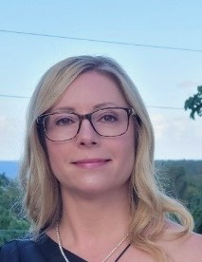  Let me be your voice. Vote me, Melissa Hodder for you Chief Steward |  | I am a permanent part time RPN and have been working with the organization for 14 years.  I currently occupy a position with the union as a steward and am wanting to take on a bigger role with the union as your Chief Steward.  RPN doesn’t just stand for Registered Practical Nurse, it also means Results, Positive, Negotiate.  Results is what I’m looking for. Positive attitude that I’ll bring. Negotiate is my favorite pass time.

Thank you and I appreciate your support.

Voting is online. Please ensure your personal email is up to date with Sandra Shank sandrashankcupe139@gmail.com to receive your link to vote. Don’t forget to check your junk mail

